Portocaval anastomoses

Definition
Communication between portal system of vein with somatic veins is portocaval anastomosis

Purpose
- They provide alternative channels for the venous return from the GIT in case of portal vein block or hepatic sinusoidal obstruction as happens in cirrhosis liver
- In such cases these enlarged channels manifest as different clinical conditions.
[HTML] portal vein formation from vivus.html[/HTML]

Sites of portocaval anastomoses
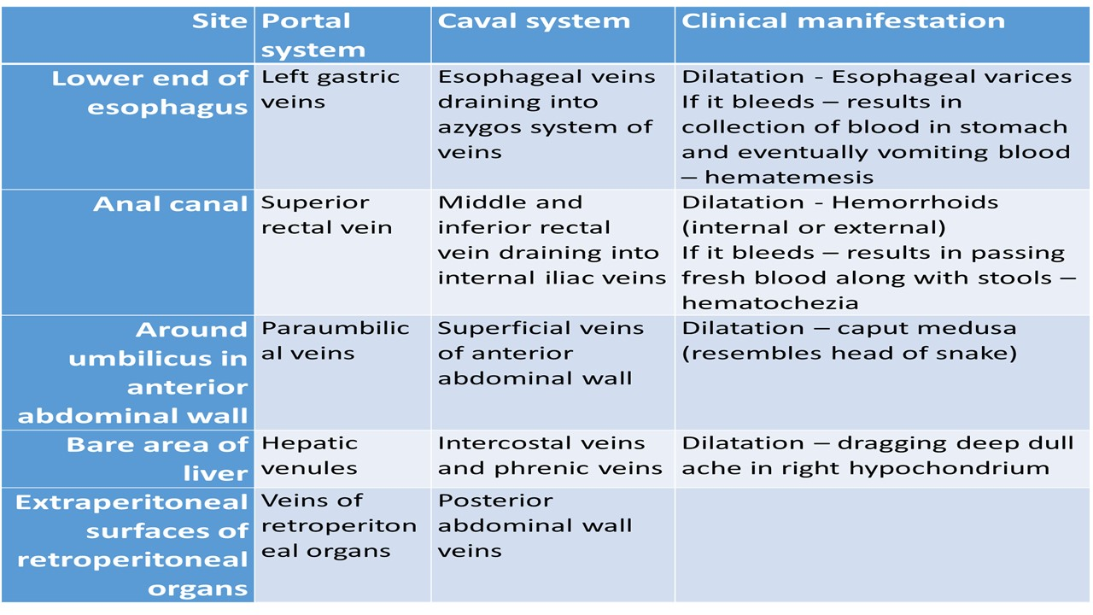
[YOUTUBE] https://www.youtube.com/watch?v=XIzpKrVcet8
[CLINICAL] Portal hypertension: Increased pressure within the portal system
[TIP] Pressures: Normal pressure : 1-4 mmHg. Below 6 mmHg

Pressure more than 6 mm Hg - Portal hypertension

Important causes
Within the liver
Liver cirrhosis

Outside the liver
Structural changes in portal vein and obstruction

Wedged hepatic venous pressure (WHVP)
Determined by wedging a catheter in a hepatic vein
Occlude the hepatic vein
Measure the pressure of proximal static blood

Hepatic venous pressure gradient (HVPG)
Clinical measurement of the pressure gradient between the WHVP and the free hepatic venous pressures

Estimate of the pressure gradient between the portal vein and the inferior vena cava

An HVPG of ≥5 mmHg defines portal hypertension

Measurement exceeds 10 mmHg it is called clinically significant portal hypertension

Above 12 mm Hg, variceal haemorrhaging may occur

[HTML] portal hypertension.html[/HTML]

MCQ_START
Q1. Portocaval anastomosis refers to:
A. Communication between hepatic veins and inferior vena cava
B. Communication between portal vein and hepatic artery
C. Communication between portal venous system and systemic (somatic) veins[CORRECT]
D. Union of splenic and superior mesenteric veins

Q2. The primary purpose of portocaval anastomoses is to:
A. Increase hepatic arterial flow
B. Provide alternative venous return in case of portal vein obstruction[CORRECT]
C. Enhance bile drainage
D. Reduce systemic venous pressure

Q3. Portal hypertension is defined when portal pressure exceeds:
A. 4 mmHg
B. 5 mmHg
C. 6 mmHg[CORRECT]
D. 12 mmHg

Q4. An HVPG (hepatic venous pressure gradient) of ≥5 mmHg indicates:
A. Normal portal pressure
B. Clinically significant portal hypertension
C. Portal hypertension[CORRECT]
D. Impending variceal hemorrhage

Q5. Clinically significant portal hypertension is diagnosed when HVPG exceeds:
A. 5 mmHg
B. 6 mmHg
C. 8 mmHg
D. 10 mmHg[CORRECT]

Q6. Variceal hemorrhage is likely to occur when portal pressure exceeds:
A. 6 mmHg
B. 8 mmHg
C. 10 mmHg
D. 12 mmHg[CORRECT]

Q7. Wedged hepatic venous pressure (WHVP) is measured by:
A. Cannulating the portal vein directly
B. Wedging a catheter in a hepatic vein and measuring proximal static blood pressure[CORRECT]
C. Measuring pressure in inferior vena cava
D. Ultrasound Doppler of portal vein

Q8. A common intrahepatic cause of portal hypertension is:
A. Portal vein thrombosis
B. Budd–Chiari syndrome
C. Liver cirrhosis[CORRECT]
D. Inferior vena cava obstruction

Q9. Portocaval anastomosis refers to:
A. Communication between hepatic veins and inferior vena cava
B. Communication between portal vein and hepatic artery
C. Communication between portal venous system and systemic (somatic) veins[CORRECT]
D. Union of splenic and superior mesenteric veins

Q10. The primary purpose of portocaval anastomoses is to:
A. Increase hepatic arterial flow
B. Provide alternative venous return in case of portal vein obstruction[CORRECT]
C. Enhance bile drainage
D. Reduce systemic venous pressure

Q11. Portal hypertension is defined when portal pressure exceeds:
A. 4 mmHg
B. 5 mmHg
C. 6 mmHg[CORRECT]
D. 12 mmHg

Q12. An HVPG (hepatic venous pressure gradient) of ≥5 mmHg indicates:
A. Normal portal pressure
B. Clinically significant portal hypertension
C. Portal hypertension[CORRECT]
D. Impending variceal hemorrhage

Q13. Clinically significant portal hypertension is diagnosed when HVPG exceeds:
A. 5 mmHg
B. 6 mmHg
C. 8 mmHg
D. 10 mmHg[CORRECT]

Q14. Variceal hemorrhage is likely to occur when portal pressure exceeds:
A. 6 mmHg
B. 8 mmHg
C. 10 mmHg
D. 12 mmHg[CORRECT]

Q15. Wedged hepatic venous pressure (WHVP) is measured by:
A. Cannulating the portal vein directly
B. Wedging a catheter in a hepatic vein and measuring proximal static blood pressure[CORRECT]
C. Measuring pressure in inferior vena cava
D. Ultrasound Doppler of portal vein

Q16. A common intrahepatic cause of portal hypertension is:
A. Portal vein thrombosis
B. Budd–Chiari syndrome
C. Liver cirrhosis[CORRECT]
D. Inferior vena cava obstruction

MCQ_END

